**Practical conservation at the landscape scale: Midlandscapes**

Author(s) … Daniel Sprod1, Andrew Cameron1, Sebastian Burgess2, Neil Davidson 2, Matt Appleby3,

Tasmanian Land Conservancy1, Greening Australia2, Bush Heritage Australia3

Australia

dsprod@tasland.org.au

*The Midlandscapes program is an enduring approach to cooperative biodiversity management within a predominantly private farming matrix in Tasmania and involves a partnership between organisations involved in conservation, restoration and natural resource management. The program protects native vegetation remnants with high natural value, establishes management regimes to facilitate survival of native flora and fauna in a changing climate, and enhances the natural value of degraded vegetation by strategically planting local native species to buffer and connect existing healthy native vegetation remnants.*

*Based on a spatially explicit Conservation Action Plan, the program has successfully engaged key landholders in the target region ; -the low (200-400m in altitude), dry (450 to 550mm rainfall) Midlands of Tasmania (640,000ha), and has built a landscape scale approach to securing, restoring and reconnecting strategic biodiversity assets. Dry grassy and woodland ecosystems are poorly conserved and are under threat within Australia and globally. Based on the best available science, the overall program goal is to have 10% of this area (64,000ha) comprising identified conservation assets managed for conservation by 2020. We are about half way to this goal, with 5% of the assets, plus another 7% of the general landscape, now under conservation management.*

*Success factors have been productive and collaborative partnerships, critically with landowners, but also across organisations; in-depth planning that includes financial and spatial modelling; and adaptive management. Future challenges include: 1. continued development of seamless cross- organisational collaboration and communication and securing ongoing funding that matches the vision. 2. effective research that provides an understanding of the needs of fauna and 3. measuring and monitoring landscape scale health and whether any changes perceived can be attributed to our intervention. Research funded through ARC- linkage is starting to provide answers about the way animals and birds use the landscape and move both within and between native vegetation remnants and is also providing information about the structural attributes required for high quality habitat as distinct from habitat that is just used for movement between patches. Genetic studies are also indicating the impacts of isolation caused by habitat clearance.*

*Following extensive planning sessions held with key landowners, a conservation enterprise model was developed to fund ongoing management of strategic assets, leveraging philanthropy via an endowment fund (the Midlandscapes Conservation Fund). Stewardship payments are made to landowners for conservation management. The payments are outcomes-based e.g. grazing management to facilitate recovery of lowland native grasslands. Recipients and amount of payment are determined through negotiation, following landowner responses to expressions of interest and bids for services. This enterprise model seeks to balance risk between the buyer and seller of conservation services. Philanthropic money and ecosystem service payments have also been successfully leveraged against government funds for protection, rehabilitation and revegetation. Plans to purchase land rich in assets have yet to bear fruit.*

*Basing the payments to landowners on their outcomes helps both the program and landowners learn by doing, and allows for adaptive and innovative management. Revegetation (of cleared land) and restoration (of degraded native bush) is initially developed by project partners, but with the potential incentive of sales of biodiversity and/or carbon credits to support ongoing management costs. Embedded into these on-ground activities are research projects; investigating eucalypt genetics to improve provenance selection, exploring innovative ground preparation and establishment regimes, and investigating how animals use vegetation remnants, to help inform future restoration design. Partnering with the peak farming organization in Tasmania to prepare an economic model has raised the possibility of developing a Voluntary Standard that outlines shared investments and shared returns for landowner and proponent in any investment in conservation or restoration.*

*To track the success of the program it is necessary to assess landscape health at intervals and demonstrate improvement. Landscape health was initially defined as health of each identified asset (e.g. extent and condition of threatened lowland native grasslands, or distribution and population demographics of Spotted tailed quoll). However, because of the diversity of assets, this has proved difficult to implement. New approaches include: state and transition modelling of critical limitations to environmental improvement, comparative studies of rates of clearing of native vegetation in protected and not protected areas, innovative remote sensing techniques (e.g. to assess structural complexity and rates of carbon sequestration) and modelling of connectivity using various approaches. Upscaling and funding monitoring to demonstrate the efficacy of interventions remains a challenge.*

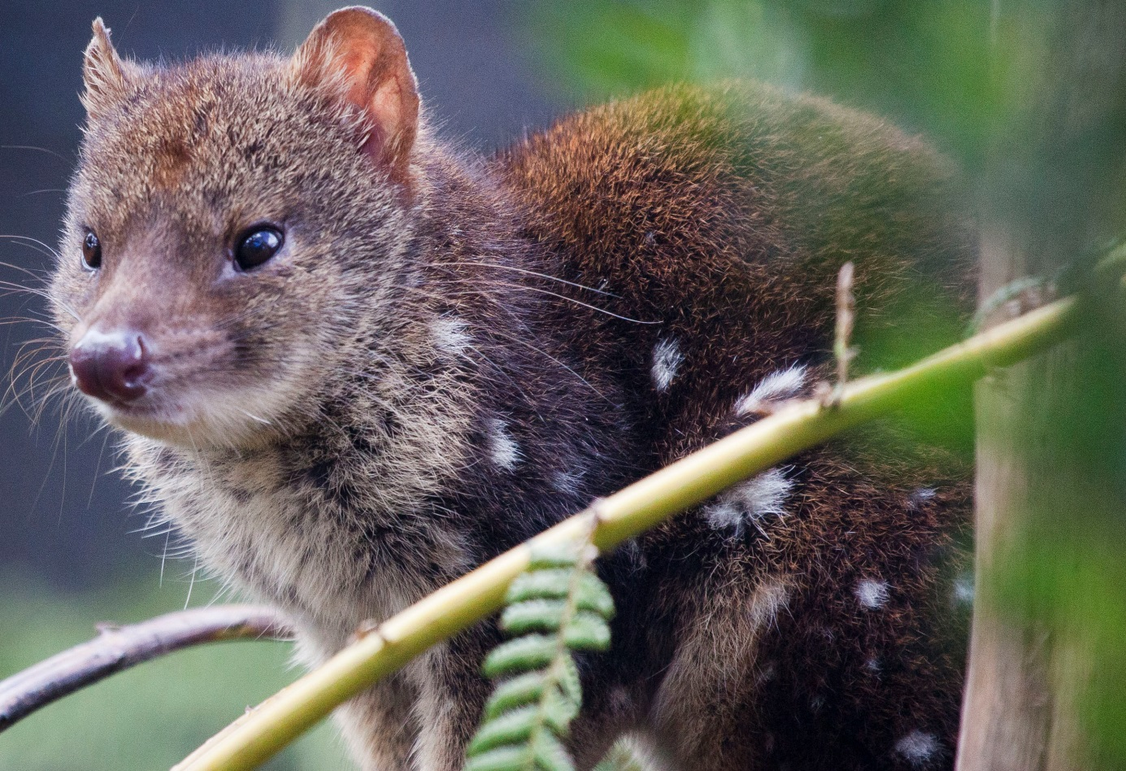

Securing habitat and restoring connectivity for the Spotted-tailed quoll (*Dasyurus maculatus*) Image: Andy Townsend

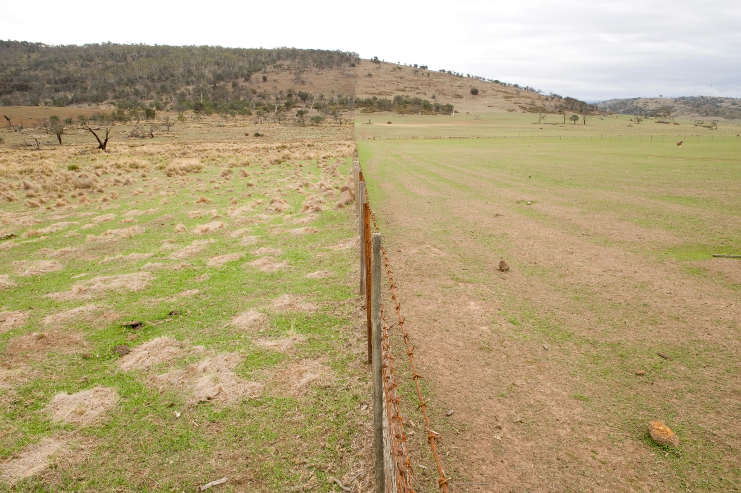

Overgrazing clearance and fragmentation of native grasslands and woodlands. Image Matt Newtown

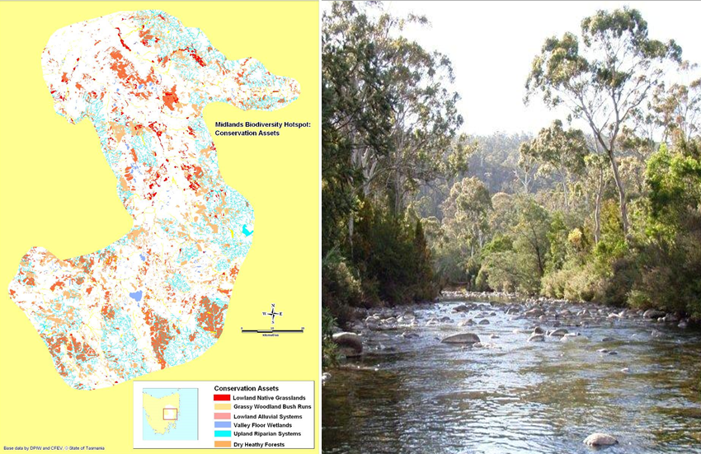

Spatial distribution of conservation assets in the Midlandscapes region Mapping Daniel Sprod, Image Diane Cameron